DT231-3 Inverter Notes
13 January 2003

1. The difference between Rectifiers and Inverters

Rectifiers convert AC to DC. Inverters convert DC to AC.

2. Uses of Inverters

Battery Backup. Batteries store DC. Many appliances use AC. An inverter can be used to generate an AC supply from a battery.

Fuel Cell power. Fuel cells are a relatively new form of power source which convert fuel (eg Hydrogen and Oxygen) directly into d.c. electricity. A fuel cell plus inverter can be used to supply a home or small business. The heat given off by the fuel cell can be used to heat the building. This is a form of CHP (combined heat and power).

A DC link may be used to connect the electricity grids of two countries. A Rectifier converts AC to DC at the sending end and an inverter converts back to DC at the receiving end. This allows the two countries to export and import electricity even if they have different frequencies. It also allows the use of long undersea cables. You cannot use long undersea cables for AC because the capacitance is too great. Example Moyle interconnector from Northern Ireland to UK.

Variable Speed Motor Drives. AC motors (induction motors and synchronous motors ) are cost effective, robust and reliable but the speed of the motor is linked very much to the supply frequency. To get good variable speed operation you need a variable frequency variable voltage supply. An inverter allows you to generate any frequency and voltage you want. A typical variable speed drive has an AC input, a rectifier generating a DC link and an inverter, which generates the variable frequency variable voltage AC to drive the motor.

Isolated DC to DC converters. Buck, boost and fly back converters can change from one DC value to another but there is no isolation between input and output. Isolation may be may be required for safety reasons. A transformer can give isolation but you cannot pass DC through a transformer. Solution: Use an inverter to chop up the DC into AC, pass the AC through a transformer and rectify it again on the other side.
Four Quadrant Operation
Inverter
DC Input
I_{out}
V_{out}
An inverter has to be able to output positive and negative current and positive and negative voltage. If the voltage and current are opposite polarity then power is actually been fed back from the AC side to the DC side. Most inverters can do this and are in fact bi-directional. They can be used as rectifiers or as inverters.
V_{out}
I_{out}
V_{out} Positive
I_{out} Positive

Power Flowing from DC to AC => Inversion

V_{out} Negative
I_{out} Negative

Power Flowing from DC to AC => Inversion

V_{out} Negative
I_{out} Positive

Power Flowing from AC to DC => Rectification

V_{out} Positive
I_{out} Negative

Power Flowing from AC to DC => Rectification

Any load with inductance or capacitance will absorb power from the ac supply at some points of the cycle and return it to the supply at others so 4 quadrant operation is essential for this type of load.

This feature is handy in some applications – e.g in an electric vehicle the drive runs as an inverter to accelerate the motor and runs as a rectifier to brake the motor and recover some of the kinetic energy by pumping it back into the battery.In a DC link between two countries bi-directional inverters allows power flow in both directions depending on who is buying and who is selling.
Common Types of Inverter

1. Older inverters used SCRs in a phase controlled inverter. These are no longer very common but may still be found at very high power levels.

2. Transistors may be used to make a square wave or quasi-square wave inverter. The switches turn on and off once per cycle. Cheap low power, low cost inverters may use this format.

3. Transistors may also be used with pulse width modulation to produce a sine wave modulated inverter. The switches turn on and off at the pwm frequency which is many time higher than the ac line frequency. and may be 10kHz or more. This is the most common type of inverter used for variable speed drives and almost always uses IGBTs
The Single Phase Full Bridge Inverter – Square Wave operation.
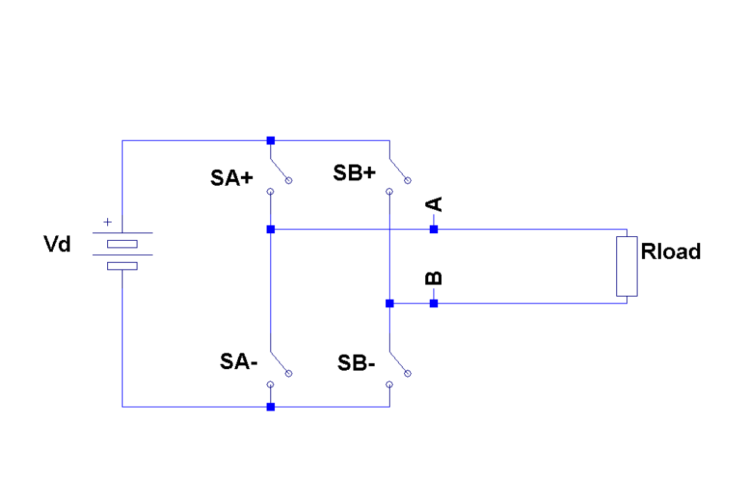
v_{o}
Square Wave Operation Output Voltage

+V_{d}
-V_{d}
time
SA+, SB-
SA-, SB+
v_{o}(t)

Parameter | Ideal Sine Wave | Square Wave Inverter
Peak Voltage | V_{m} | V_{d}
RMS Voltage | 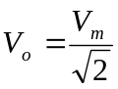 | 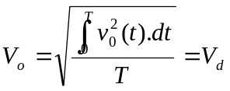
Fundamental | 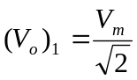 | 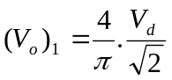
Total Harmonic Distortion | 0 | 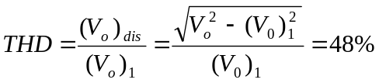

Significance of the peak voltage:

Any equipment with a rectifier will respond to the peak voltage (eg most electronic equipment)

Significance of the rms voltage:

Any device using electricity to generate heat will respond to the rms voltage (eg cookers, light bulbs)

Significance of the fundamental voltage

Any device that has low pass characteristics which includes motors and almost any electromechanical device will respond to the fundamental component of the voltage.

In a square wave inverter it will not be possible to get the correct peak, rms and fundamental all at the same time.
Square Wave Inverter with Dead Time (Quasi Square Wave)

Parameter | Ideal Sine Wave | Square Wave Inverter
Peak Voltage | V_{m} | 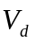
RMS Voltage |  | 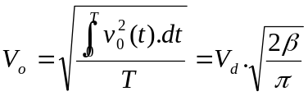
Fundamental | 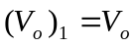 | 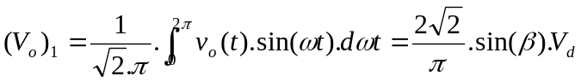
Total Harmonic Distortion | 0 | 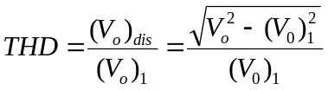

Special Case:
+V_{d}
-V_{d}
ωt
SA+, SB-
SA-, SB+
v_{o}(t)

β

If β=π/4 then the waveform has the same peak to rms ratio as a pure sinewave. Cheap low cost low power inverters employ this type of waveform to generate an output of correct peak and correct rms voltage. The fundamental is still incorrect however and this could cause problems for motor loads.

Exercise. Calculate the fundamental and total harmonic distortion for this special case.
Inverter with an Inductive Load
v_{AB}
i_{o}
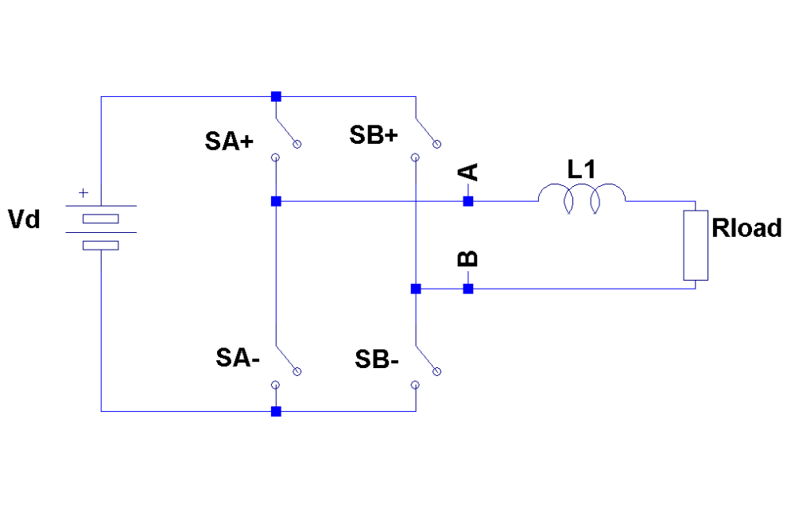

ωt
v_{AB}
i_{o}
X
X
X

In the Regions marked X the voltage and current are opposite polarity (Rectifying Quadrant). This means that the current is flowing backwards through the switches (From Negative to Positive). Most transistors (Bipolars, IGBTS) cannot handle reverse currents so reverse diode are needed across the transistors to take the reverse currents. Note that Mosfets have an intrinsic reverse diode. Be careful however often the intrinsic body diode is much slower and has a lower current rating than the mosfet itself.
Full Bridge Circuit with IGBTs

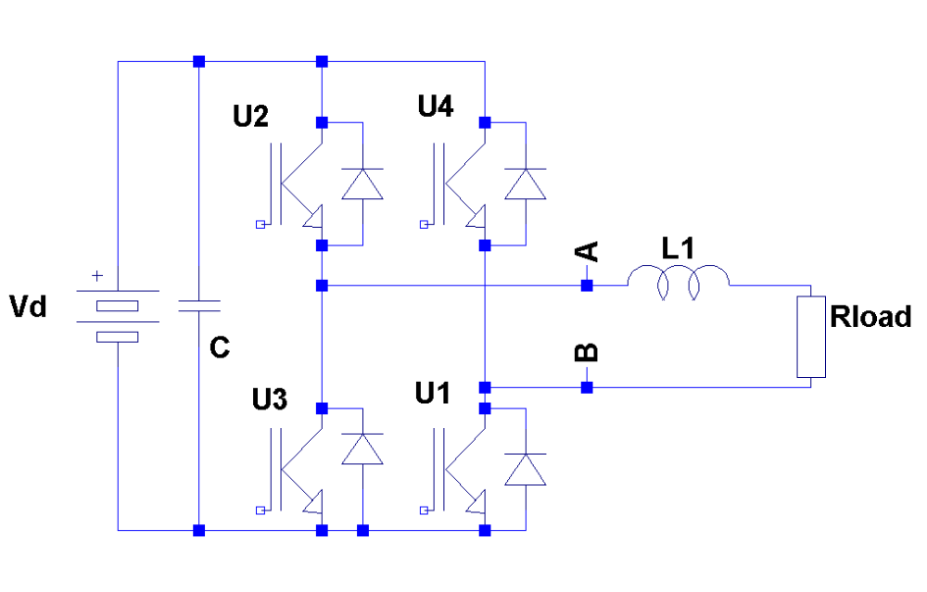
The reverse diodes are essential to allow reverse currents. In fact the diodes conduct whenever the bridge is operating in a rectifying quadrant.

The DC bus capacitance absorbs ripple currents associated with switching. In theory if the load is purely resistive and full square wave operation is used then the current out of the supply is constant dc, In reality even in this case dc bus capacitance is needed (as close to the IGBTs as possible) to compensate for stray inductance in the circuit and stabilise the voltage at the IGBTs.

